Apache Hive – Complete Guide

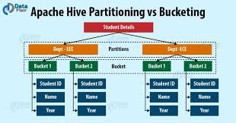

1. Apache Hive – Detailed Definition
Apache Hive is a distributed SQL data warehouse system built on top of Hadoop ecosystem storage such as HDFS or cloud object storage (S3, ADLS, GCS).
Hive allows data engineers and analysts to query massive datasets (TB–PB scale) using SQL-like language called HiveQL, without writing complex distributed processing code.
Internally, Hive does not execute queries itself.
It translates SQL queries into distributed execution plans that run on engines such as Spark, Tez, or MapReduce.
Hive is optimized for batch analytics, not transactional or real-time workloads.

2. Why Hive Exists (Problem It Solves)
Before Hive, processing big data required writing low-level MapReduce programs, which were complex and time-consuming.
Hive solves this by:
Allowing SQL-based analytics on big data
Hiding distributed system complexity
Enabling schema-on-read for data lakes
Supporting large batch ETL and reporting
Hive is widely used in data lakes, log analytics, historical reporting, and offline BI pipelines.

3. Hive vs MySQL vs MongoDB
Execution Model
MySQL executes queries row-by-row on a single server or limited replicas.
MongoDB processes documents with aggregation pipelines.
Hive executes queries by scanning large files in parallel across a cluster.
Data Size
MySQL handles GB-level to small TB datasets efficiently.
MongoDB scales horizontally but is not optimized for heavy analytical SQL.
Hive is designed for TB to PB scale analytics.
Use Case
MySQL is best for OLTP systems.
MongoDB is best for flexible schema and high write throughput.
Hive is best for batch analytics and data warehousing.

4. Hive Architecture (Conceptual)
Hive consists of:
Hive Client (CLI / JDBC / Beeline)
Hive Server (accepts SQL queries)
Metastore (stores table schema and metadata)
Execution Engine (Spark / Tez / MapReduce)
Distributed Storage (HDFS or cloud storage)
Hive stores metadata in a relational database, but actual data lives in files.

5. Apache Hive Setup Using Docker (Step by Step)
This setup is for learning and practice, not production.
Step 1: Prerequisites
docker installed
docker Compose installed

Step 2: Create docker-compose.yml
And write the below code

services:
metastore-db:
image: mysql:5.7
environment:
MYSQL_ROOT_PASSWORD: hive
MYSQL_DATABASE: metastore
MYSQL_USER: hive
MYSQL_PASSWORD: hive
ports:
- "3307:3306"

hive-metastore:
image: apache/hive:3.1.3
depends_on:
- metastore-db
environment:
SERVICE_NAME: metastore
ports:
- "9083:9083"

hive-server:
image: apache/hive:3.1.3
depends_on:
- hive-metastore
environment:
SERVICE_NAME: hiveserver2
ports:
- "10000:10000"

Open the command prompt first verify docker running or not
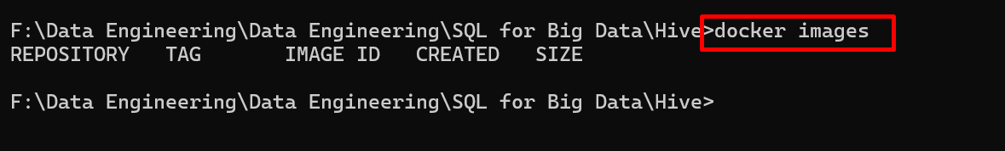

Step 3: Start Hive
docker-compose up -d

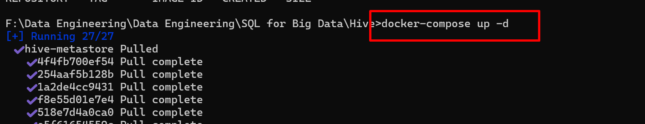

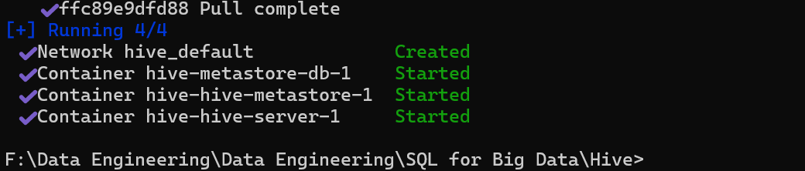

Using docker ps check running containers or services

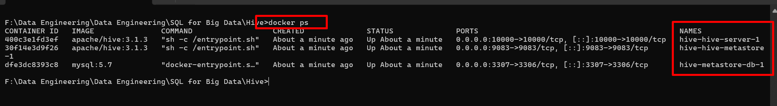

Step 4: Connect to Hive
docker exec -it hive-hive-server-1 beeline
please check the container name.
please check the container name running with port number 10000

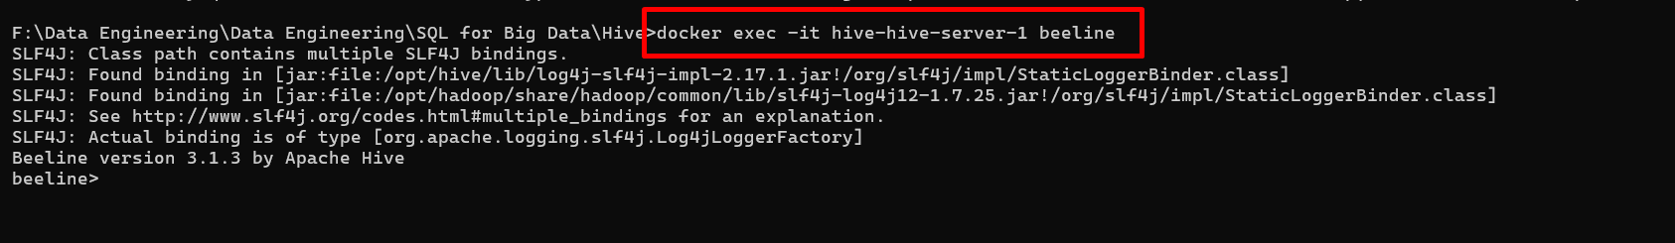

!connect jdbc:hive2://localhost:10000
Hive is now ready.

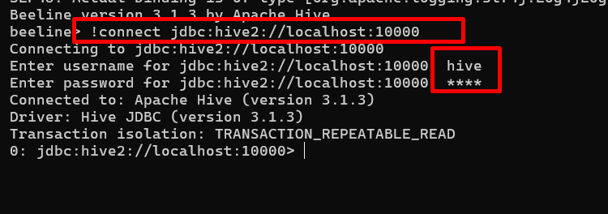

Here user name is hive and password is hive

Connect to Beeline run below command
SET hive.metastore.warehouse.dir=/tmp/hive/warehouse;
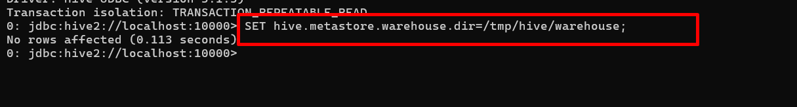

6. Hive Data Model Basics
Hive tables map to directories(equal to table in mysql and collection in mongo db)
Rows map to files (record in mysql and document mongo db)
Columns map to fields inside files
Hive uses schema-on-read, meaning data is interpreted at query time.

7. BASIC LEVEL HIVE QUERIES
Create Database
CREATE DATABASE sales_db;
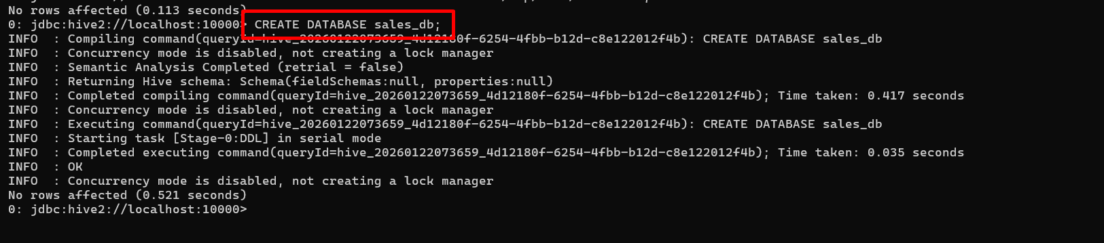

USE sales_db;
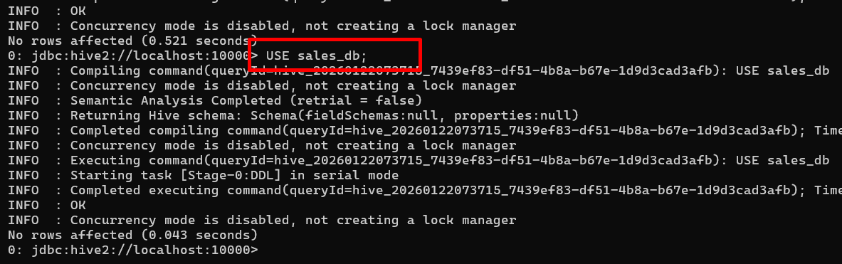

Create Table
CREATE TABLE orders (
order_id INT,
customer_id INT,
amount DOUBLE
)
ROW FORMAT DELIMITED
FIELDS TERMINATED BY ',';

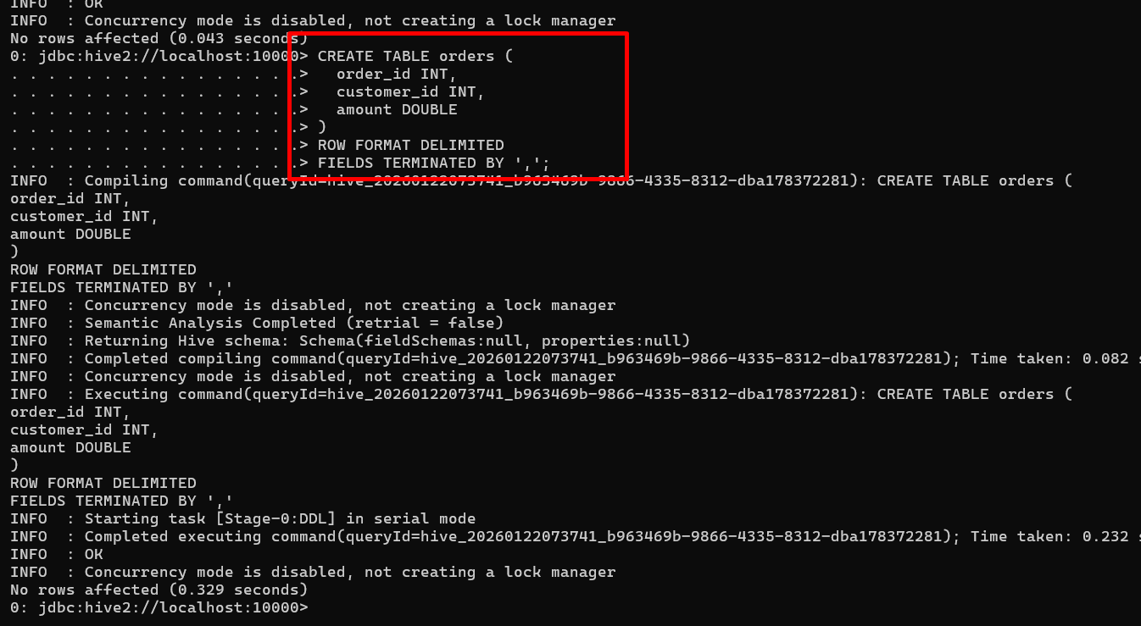

Insert Data
INSERT INTO orders VALUES
(1,101,500),
(2,102,700),
(3,101,900);
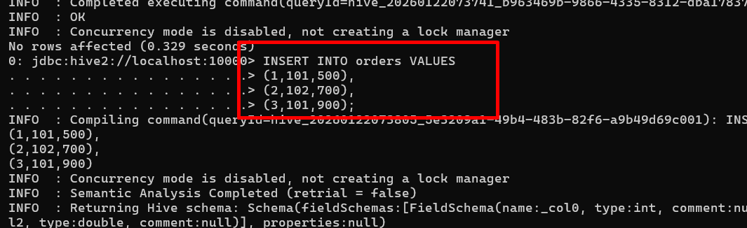
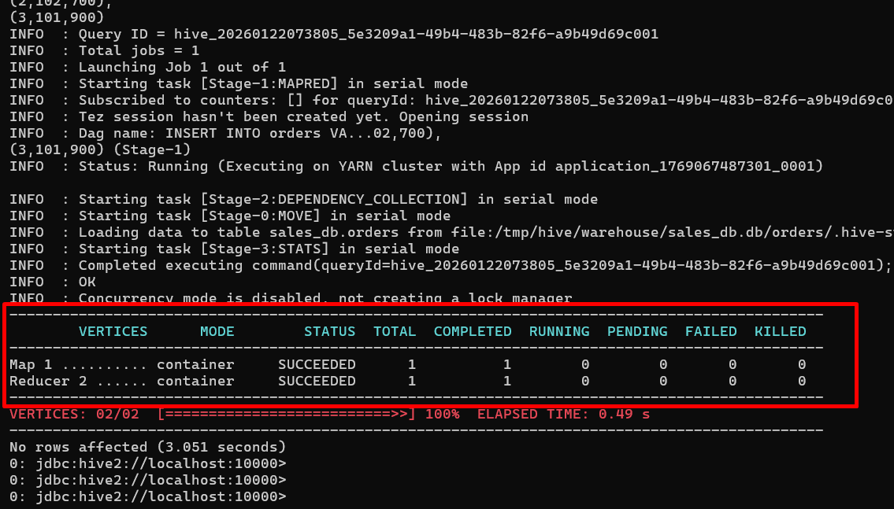

Simple Query
SELECT * FROM orders;
What Happens Internally
Hive scans all underlying files and returns matching rows.

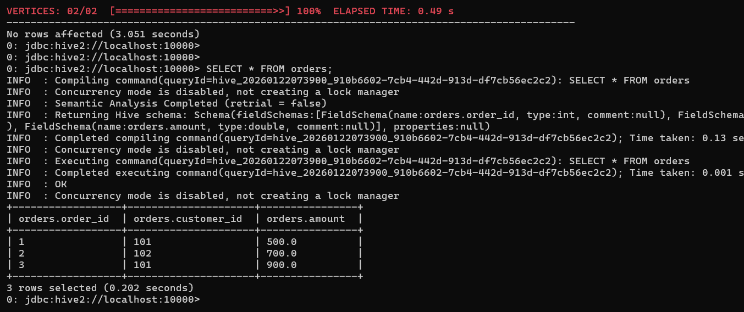

Aggregation Query
SELECT customer_id, SUM(amount)
FROM orders
GROUP BY customer_id;

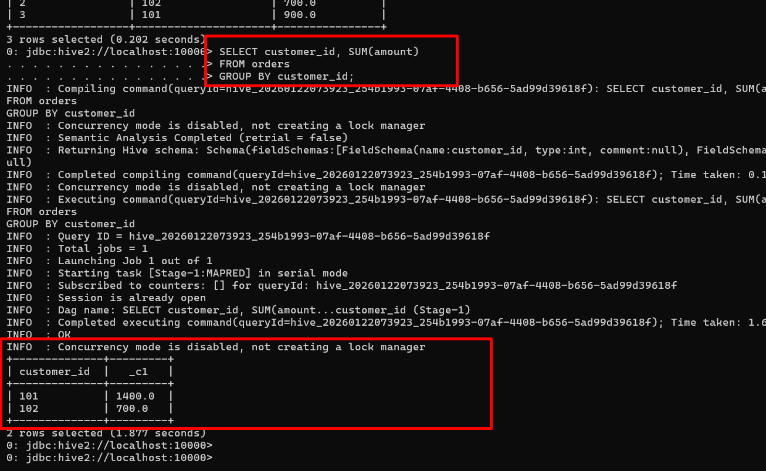

Hive distributes aggregation across nodes and merges results.

8. INTERMEDIATE LEVEL HIVE QUERIES
Partitioning
Create Partitioned Table
CREATE TABLE orders_part (
order_id INT,
customer_id INT,
amount DOUBLE
)
PARTITIONED BY (order_date STRING);

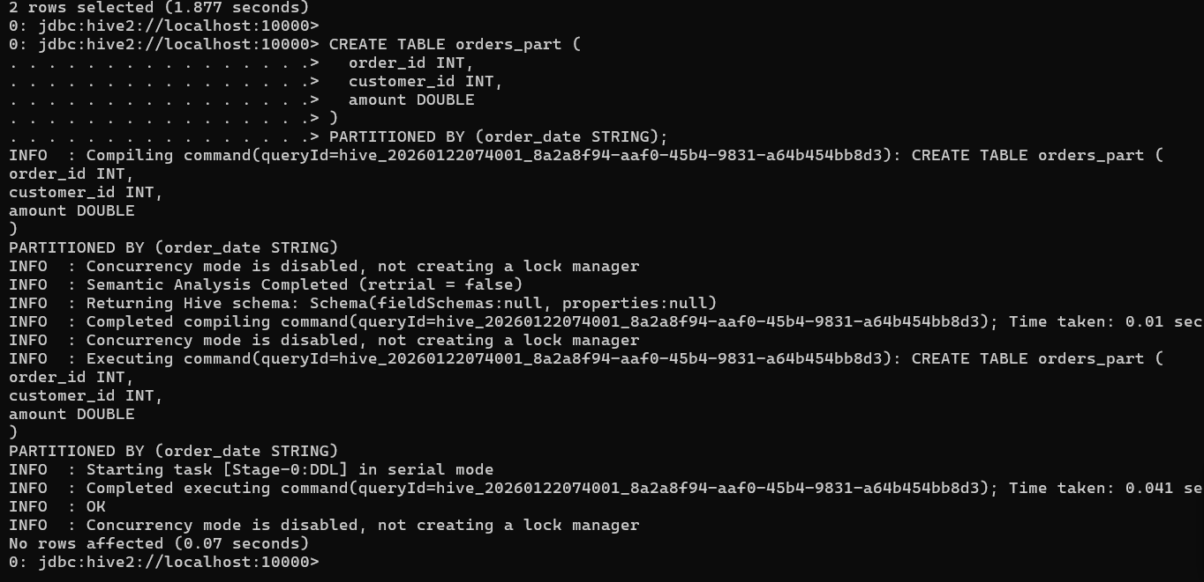

Insert Data into Partition
INSERT INTO orders_part PARTITION (order_date='2025-01-10')
VALUES (1,101,500);

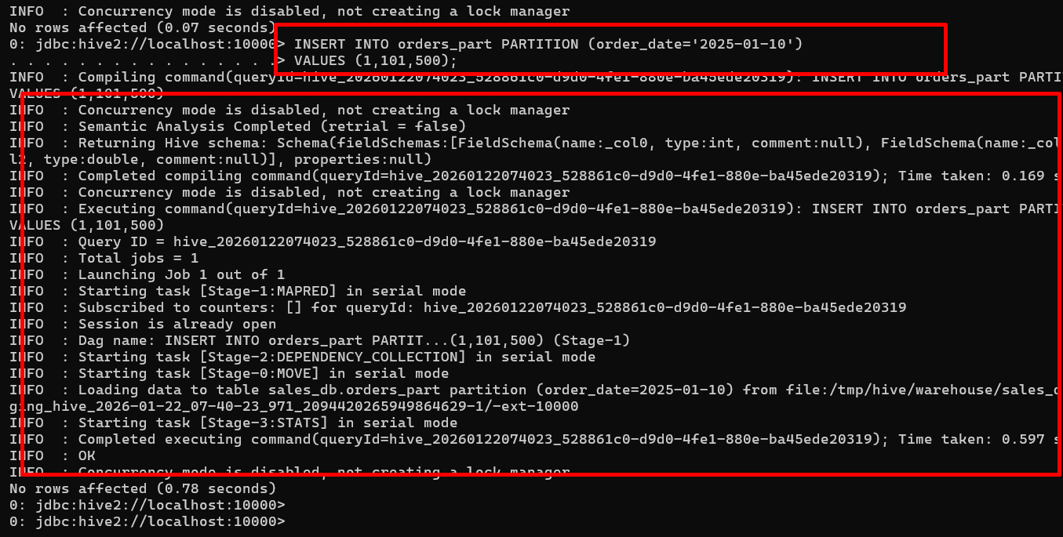

Query with Partition Filter
SELECT SUM(amount)
FROM orders_part
WHERE order_date='2025-01-10';

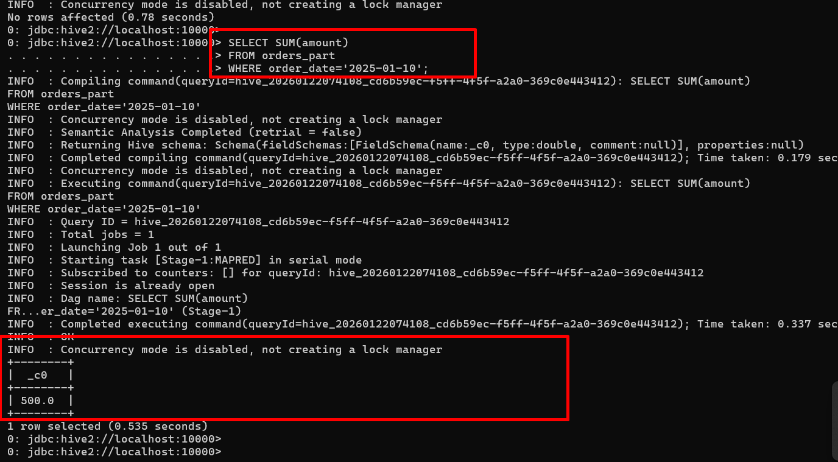

What Happens Internally
Hive reads only the directory for order_date=2025-01-10.
This is called partition pruning.

Create another able as customer

CREATE TABLE customers (
id INT,
name STRING,
city STRING
)
ROW FORMAT DELIMITED
FIELDS TERMINATED BY ',';

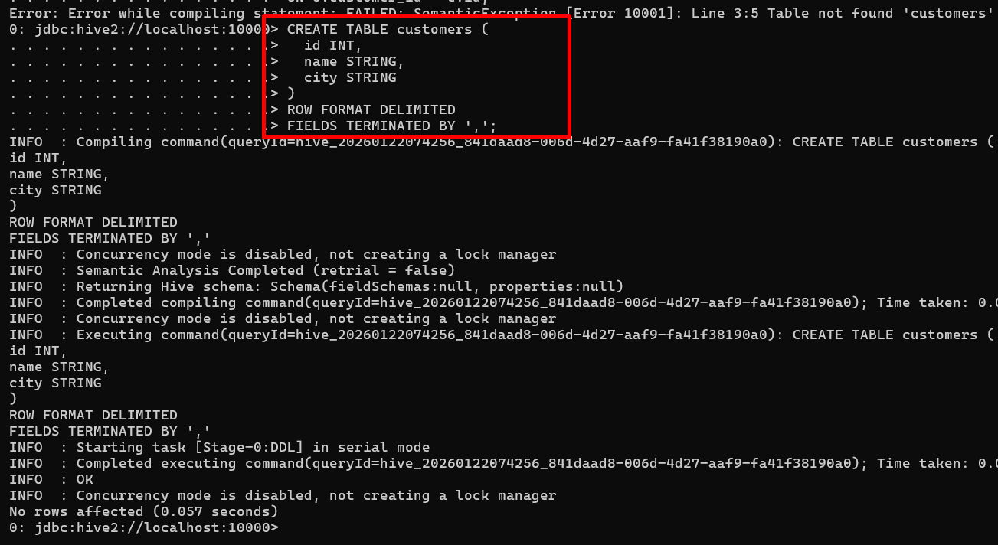

INSERT INTO customers VALUES
(101,'Akash','Pune'),
(102,'Rahul','Mumbai'),
(103,'Sneha','Bangalore'),
(104,'Neha','Delhi');

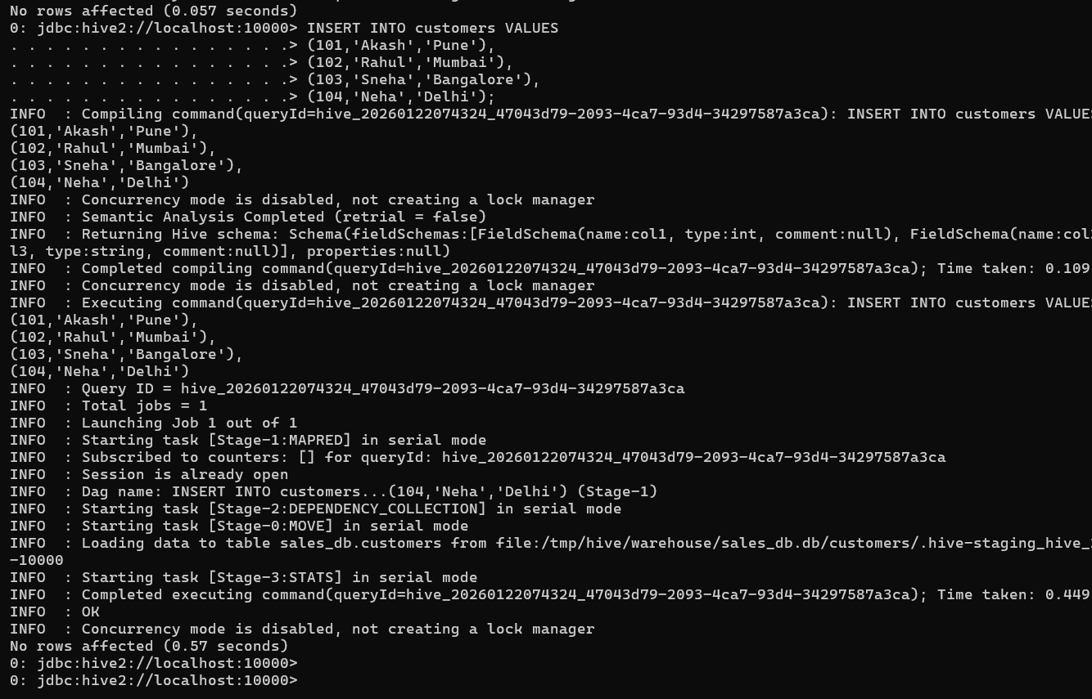

Joins in Hive
SELECT o.order_id, c.name
FROM orders_part o
JOIN customers c
ON o.customer_id = c.id;
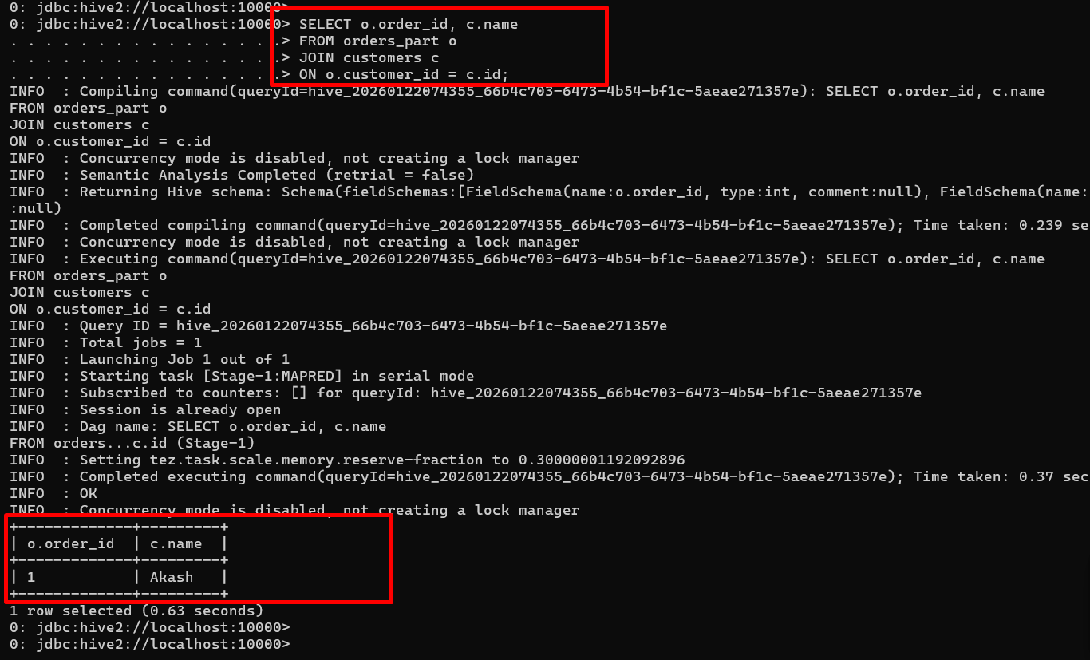

Hive performs distributed joins using execution engines like Spark.

9. ADVANCED LEVEL HIVE QUERIES
Bucketing
Create Bucketed Table
CREATE TABLE orders_bucketed (
order_id INT,
customer_id INT,
amount DOUBLE
)
CLUSTERED BY (customer_id) INTO 4 BUCKETS;

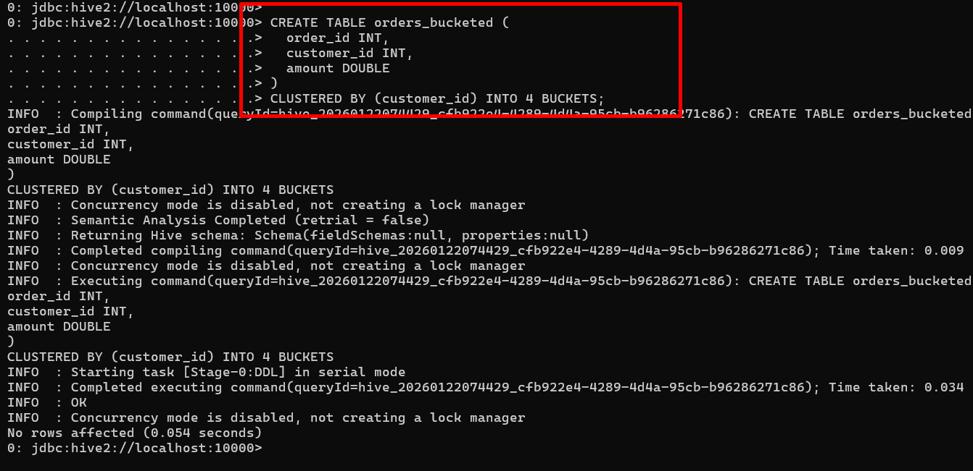

Bucketing improves join and aggregation performance.

Partition + Bucketing
CREATE TABLE orders_adv (
order_id INT,
customer_id INT,
amount DOUBLE
)
PARTITIONED BY (order_date STRING)
CLUSTERED BY (customer_id) INTO 8 BUCKETS;

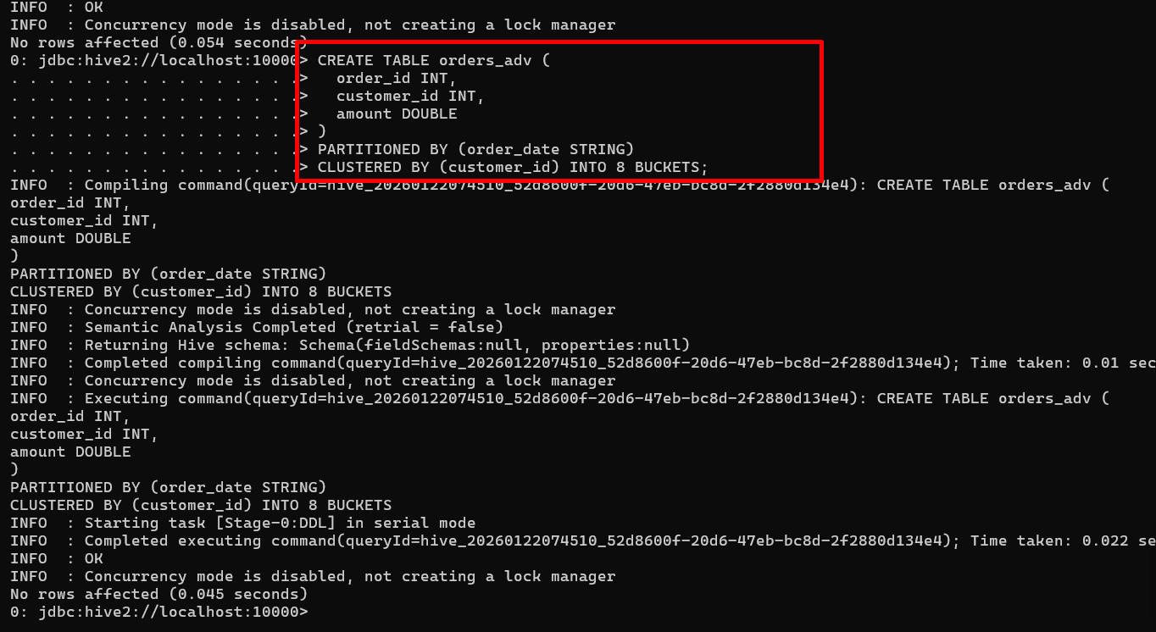

Hive first prunes partitions, then uses buckets for efficient processing.

Window Functions
SELECT customer_id,
amount,
RANK() OVER (PARTITION BY customer_id ORDER BY amount DESC) AS rnk
FROM orders_part;

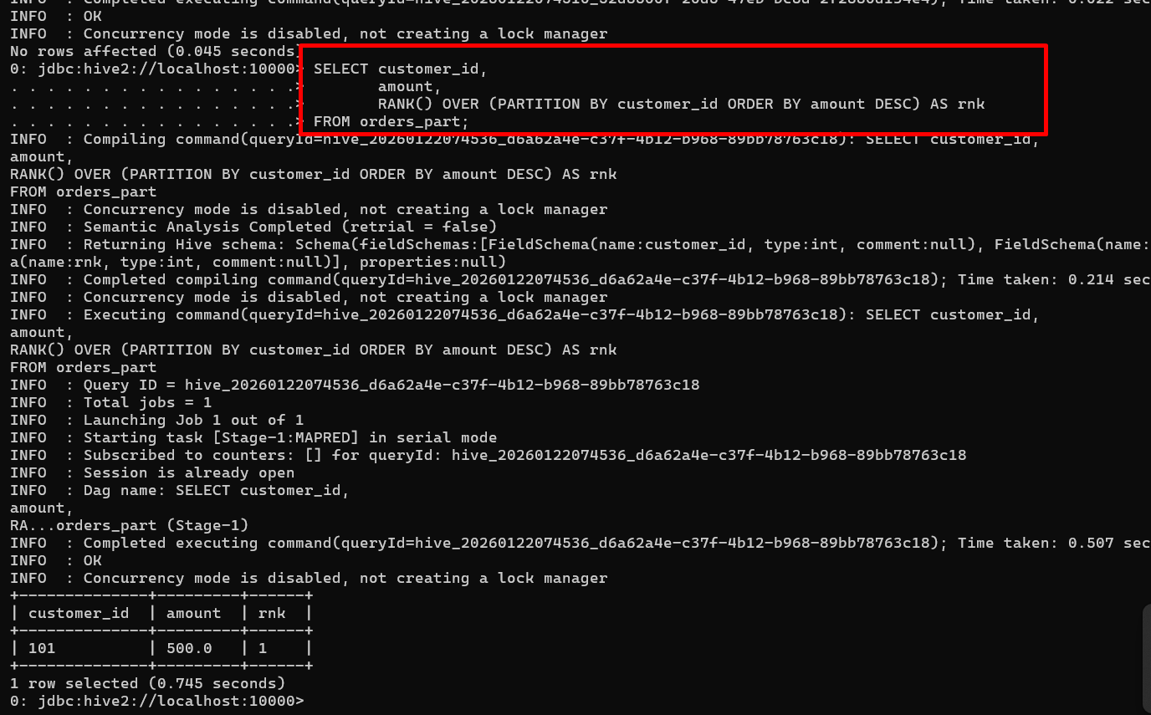

Used for analytics such as ranking and running totals.
10. What Hive Is NOT Good At
Hive is not suitable for:
Real-time queries
High-frequency inserts
Row-level updates
OLTP systems
Hive is strictly for batch analytics.
To quite hive terminal write the command as
Cntr +C

Final Summary
Apache Hive enables SQL-based analytics on massive datasets by translating queries into distributed execution plans. It is best suited for data lakes, historical analysis, and batch ETL pipelines. Docker-based setups are excellent for learning HiveQL, partitioning, bucketing, and query optimization, while production deployments typically run on cloud or Hadoop clusters.

If you want next, I can provide:
Complete sample dataset for practice
Same queries compared with MySQL execution
Hive performance tuning tips
Interview questions and answers on Hive
OR step-by-step Spark vs Hive comparison

